Science Quest 10 Chapter 6: The mysterious universe
Individual Pathways
Testmaker 6.2

 | What is the name of the current theory about the origin of the universe?  - The oscillating universe  - The steady-state universe  - The big bang  - The expanding universe | C | 1
 | The apparent slow motion of the stars that is observed during the night is due to:  - the orbit of stars around other stars.  - the orbit of the Earth around the sun.  - the effect of parallax.  - the rotation of the Earth. | D | 1
 | A galaxy is:  - a cloud of dust and gas.  - a group of stars.  - an exploding star.  - a group of planets. | B | 1
 | Energy is emitted from the sun as a result of:  - chemical reactions.  - nuclear fission.  - nuclear fusion.  - the burning of hydrogen. | C | 1
 | The Hertzsprung–Russell diagram is a graph of:  - absolute magnitude versus apparent magnitude.  - absolute magnitude versus mass.  - absolute magnitude versus surface temperature.  - spectral colour versus temperature. | C | 1
 | The observed red shift of some stars is due to their:  - extremely high temperature.  - extremely low temperature.  - movement towards the Earth.  - movement away from Earth. | D | 1
 | Hubble’s law states that:  - the majority of galaxies are moving away from the Earth.  - the majority of galaxies are moving towards the Earth.  - more distant galaxies move away from the Earth faster.  - the universe is expanding at an increasing rate. | C | 1
 | The ‘big bang’ theory is a possible explanation of:  - the birth of a star.  - the expansion of the universe.  - the collapse of the universe.  - the formation of the solar system. | B | 1
 | According to the ‘big bang’ theory, all that existed before the universe began was:  - mass.  - energy.  - space.  - time. | B | 1
 | According to the ‘big bang’ theory, the universe is:  - ripping itself apart.  - rotating.  - getting warmer.  - cooling. | D | 1
 | The age of the universe is believed by cosmologists to be closest to:  - 15 thousand years.  - 15 million years.  - 15 billion years.  - 15 trillion years. | C | 1
 | The atoms that came together to form the first stars were pulled together by:  - electric forces.  - magnetic forces.  - gravity.  - friction. | C | 1
 | The light-year is a unit of:  - brightness.  - distance.  - speed.  - time. | B | 1
 | Our solar system is a part of the:  - Andromeda galaxy.  - Magellanic clouds.  - Milky Way galaxy.  - Orion constellation. | C | 1
 | Inward-looking satellites may be used for:  - observing stars.  - listening for signs of extraterrestrial life.  - communications for television, radio and computer data.  - watching for asteroids that may hit the Earth. | C | 1
 | A nebula is:  - a cloud of dust and gas.  - a group of stars.  - an exploding star.  - a fixed pattern of stars. | A | 1
 | In the sun, hydrogen is transformed into:  - carbon dioxide.  - helium.  - oxygen.  - water. | B | 1
 | Compared to other stars in the universe, the mass of the sun could be best described as:  - huge.  - average.  - small.  - similar. | B | 1
 | Which of the following is described as a nursery of the stars?  - Nebula  - Nova  - Red giant  - White dwarf | A | 1
 | The colour of a star is most directly related to its:  - age.  - location.  - surface temperature.  - volume. | C | 1
 | Which of the following is not used by the Hubble Space Telescope to collect data?  - Visible light  - X-rays  - Infra-red radiation  - Ultraviolet radiation | B | 1
 | Which observation by scientists provides evidence for the changes that occur during the lifetime of a star?  - The occurrence of supernovae  - The emission of energy from the sun  - The greenhouse effect  - The discovery of distant galaxies | A | 1
 | Which of the following statements does not describe a red giant?  - A red giant begins to form as helium builds up in the core of a star.  - A red giant is a star that swells to many times its original size.  - A red giant is a very large, stable, middle-aged star like the sun.  - A red giant is a star in which a new fusion process takes place, turning helium into heavier elements. | C | 1
 | Which statement is the best description of the universe?  - A collection of stars, separated by absolutely empty space  - A collection of galaxies, nebulae and stars  - A collection of solar systems separated by empty space  - The Milky Way galaxy, made of stars and planets | B | 1
 | A supernova is the name given to:  - the beginnings of a brand new star.  - the core of an exploded star.  - the end stage of a very massive star.  - the end stage of a very small star. | C | 1
 | Which statement describes evidence that is the basis of the big bang theory?  - All galaxies have been measured to be moving at the same speed.  - Distant galaxies have been measured to be moving away from the Earth faster than closer galaxies.  - All stars have been measured to be moving at the same speed.  - Galaxies are expanding as the stars within the galaxy move away from each other. | B | 1
 | Stars with a mass less than eight times the mass of our sun will evolve to finally form a:  - planetary nebula.  - red giant.  - white dwarf.  - black dwarf. | D | 1
 | The word ‘planet’ is derived from the Greek words planetes asteres, which means ‘wandering stars’. Explain why the word ‘planet’ comes from the term ‘wandering stars’. | The planets look like stars that wander about among the fixed pattern of stars. | 1
 | The red shift of moving stars can be explained by a phenomenon known as the Doppler effect. Describe another example of the Doppler effect that can be observed on Earth. | A fast-moving train or car passing by. As the vehicle moves towards or away from an observer, the frequency of the sound changes. | 2
 | How do astronomers know what elements are present in a star that is millions of kilometres away? | By analysing the spectrum of light emitted by the star and comparing it with known spectra on Earth | 2
 | List two reasons why outward-looking satellites in space produce clearer images of distant galaxies than Earth-based telescopes. | Answer should include two of the following: no light pollution, unobstructed by atmosphere, no chemical pollution, no dust. | 2
 | Explain how you could demonstrate the parallax effect with two pencils. | Hold the pencils at different distances in front of your eyes and move your head sideways. The pencils will appear to move relative to each other. | 2
 | Explain why we do not know that a distant star has exploded until millions of years after it happens. | The light from the exploding star takes millions of years to reach Earth. We cannot see it until the light arrives. | 2
 | The following drawing shows a model of the universe.  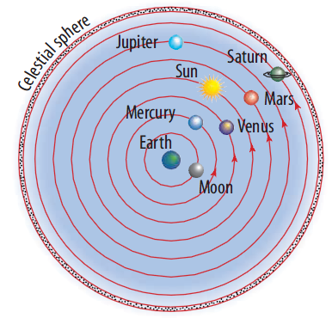  - Is this a geocentric or heliocentric model?  - Name the astronomer who suggested this model. | - Geocentric  - Ptolemy | 2
 | Three stages (A, B and C) during the big bang are shown in the following diagram.  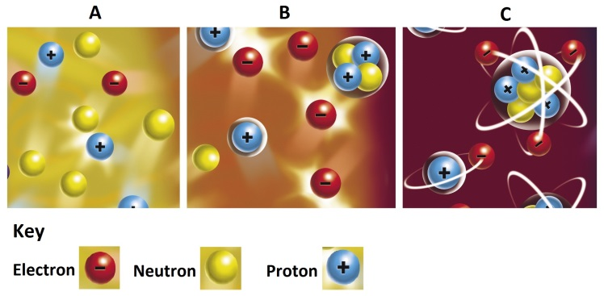  - Stage A shows the presence of protons, neutrons and electrons. Which of these particles was the first to form?  - Identify the new structure formed in stage B.  - Identify the new structure in stage C. | - Electrons  - Nucleus  - Atom | 3
 | The table below compares the apparent and absolute magnitudes of three different stars. Which of the stars in the table:  - is the brightest as seen from Earth  - has the least actual brightness? | - Sirius  - Sirius | 2
 | List three different uses of inward-looking satellites. | Examples of possible answers include: gathering weather data or predicting weather; mineral exploration; crop analysis; erosion detection; military defence, offence or spying; communication. (Other answers are possible.) | 3
 | How does the parallax effect help explain the apparent motion of the stars relative to each other? | Objects that are different distances from an observer appear to move relative to each other when the observer moves from side to side. From the Earth, the stars appear to move relative to each other due to the fact that they are different distances from an observer who is moving with the Earth as it orbits the sun. | 3
 | The sun has an apparent magnitude of –27 and an absolute magnitude of +4.7.  - What is the difference between the apparent magnitude and absolute magnitude of a star?  - Explain why these two measures of magnitude for the sun are so different. | - Absolute magnitude is a measure of actual brightness; apparent magnitude is a measure of brightness as seen from Earth.  - Although the sun is not very bright compared to many other stars, it appears brighter because it is much closer to Earth. | 3

